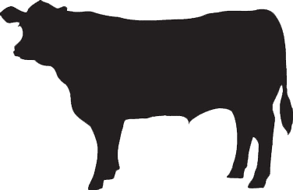
Beef Cutting Instruction Form
Customer Info:
Name:___________________________
Phone #: _________________________
Email: ___________________________

Beef Slaughter Date: ____________
(Beef Hangs for a minimum of 2 ½ weeks before cutting)

Portion Size:
- Whole
- Half
- Quarter

** Please Select Below All the Options you Desire! **
Wrapping:
- White Paper ($.75/lb.)
- Vac Packed ($1.25/lb.)

*How many lbs. would you like you Roasts cut at? (Roast Size is typically 3-4 lbs. each.) ________

*How thick would you like your steaks? (Steak Thickness is typically ¾ in.) ________

*How many steaks per package?
- 1 Steak per Pack
- 2 Steaks per Pack
- 4 Steaks per Pack

LOIN (CHOOSE 1 OPTION)
- T-Bone Steaks
- New York Strips & Filets

RIB (Multiple Options)
- Ribeye Steaks
- Rib Roast (How many lbs.? ____)

CHUCK (Multiple Options)
- Arm Roasts
- Arm Steaks
- Grind Arm to Burger
- Chuck Roasts
- Chuck Steaks
- Grind Chuck to Burger
Owner: Jenny Flint
815-651-5555
FamilyFarmMeats@gmail.com
Store Hours:
Tues.-Thur. 10-2
Fri. 10-4
Sat. 9-2

BRISKET (CHOOSE 1 OPTION)
- Left Whole
- Cut in ½
- Grind to Burger

GROUND BEEF 80/20 (CHOOSE 1 OPTION)
- 1 lb. Packages
- 1 ½ lb. Packages
- 2 lb. Packages

SIRLOIN (Multiple Options)
- Sirloin Steak
- Sirloin Tip Roast
- Tri Tip Roast
- Grind to Burger

ROUND (Multiple Options)
- Round Steaks
- Round Roast
- Ground Round 90/10
- Rump Roast
- Grind to Burger

SHANK, PLATE & FLANK
(Multiple Options)
- Short Ribs
- Flank Steak
- Skirt Steak
- Soup Bones

MISC. CUTS (Multiple Options)
- Stew Meat
(If yes, how many 1lb. packages? _____)
- Cube Steak
- Heart
- Tongue
- Liver
- Oxtail

NOTES:

