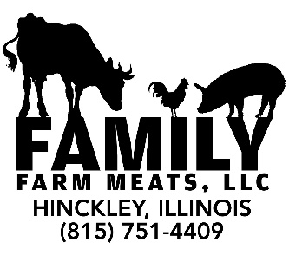
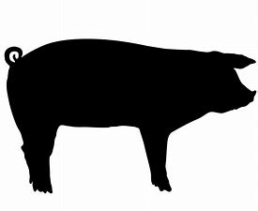
Owner: Jenny Flint
815-651-5555
FamilyFarmMeats@gmail.com
Store Hours:
Tues.-Thur. 10-2
Fri. 10-4
Sat. 9-2

Hog Cutting Instruction Form
Customer Info:
Name:___________________________
Phone #: _________________________
Email: ___________________________

Hog Slaughter Date: _____________
Portion Size:
- Whole
- Half

** Please Select Below All the Options you Desire! **
Wrapping:
- White Paper ($.75/lb.)
- Vac Packed ($1.25/lb.)

SHOULDER (Multiple Options)
- Shoulder Steaks
- Shoulder Roasts
>If Yes, How many lbs. Each? ______
- Grind for Sausage

LOIN (CHOOSE 1 OPTION)
- Butterfly Chops
- Back Ribs
- Pork Tenderloin
- Spare Ribs
- Boneless Chops
- Back Ribs
- Pork Tenderloin
- Spare Ribs
- Bone In Chops
- Spare Ribs ONLY

NOTE: IF you choose Butterfly or Boneless chops you get Back Ribs, Spare Ribs and Tenderloin. IF you choose Bone In Chops you only get Spare Ribs!

NOTES:

BELLY (CHOOSE 1 OPTION)
- Bacon Cured 1 lb. Packs
- SLICED Pork Belly/Side Pork
- Pork Belly Left Whole

LEG (Multiple Options)
- Fresh Hams (Not Smoked or Cured)
>If yes, How many lbs. Each? _____
- Smoked Hams
>If yes, How many lbs. Each? _____
- Smoked Ham Steaks
- Grind for Sausage

MISC. CUTS (Multiple Options)
- Neck Bones
- Liver
- Lard
- Jowls
SAUSAGE
*HALF HOG gets up to 2 Sausage Options
*WHOLE HOG gets up to 3 Sausage Options
(Brats, Links or Patties are an additional charge per lb.)
- Breakfast Sausage Bulk 1lb. Pack
- Breakfast Sausage Links
- Breakfast Sausage Patties
- Hot Breakfast Sausage Bulk 1lb. Pack
- Italian Sausage Bulk 1 lb. Pack
- Italian Sausage Links
- Ground Pork Bulk 1 lb. Pack
- Seasoned Pork Patties
- Bratwurst Patties
- Fresh Brats
- Beer Brats
- Cheddar Brats
- Mushroom & Swiss Brats

ALL CURED MEAT TAKES AN ADDITIONAL 30 DAYS FROM DATE BUTCHERED

